

A
Industrial Oriented Mini Project Report
on

TALENT LINK – A PROFESSIONAL FREELANCER PLATFORM
Submitted to

Jawaharlal Nehru Technological University, Hyderabad
For the partial fulfilment of requirements for the award of the degree in

BACHELOR OF TECHNOLOGY
in

COMPUTER SCIENCE AND ENGINEERING
Submitted by
ADI ROSHINI | (23271A05D9)
VATARIKARI MANISHA | (23271A05C8)
ARMOOR AKHILA | (23271A05B9)
ARANDKAR VAESHNAVI | (23271A05G3)
Under the Esteemed guidance of
DR. M. RAVINDAR
Associate Professor Dept. of CSE

DEPARTMENT OF COMPUTER SCIENCE AND ENGINEERING JYOTHISHMATHI INSTITUTE OF TECHNOLOGY AND SCIENCE
(Autonomous, NBA (CSE, ECE, EEE) and NAAC ‘A’ Grade)
(Approved by AICTE, New Delhi, Affiliated to JNTUH, Hyderabad) Nustulapur, Karimnagar 505481, Telangana, India
2025-2026

CERTIFICATE

This is to certify that the Industrial Oriented Mini Project Report entitled “ Talent Link – A professional freelancer platform” is being submitted by ADI ROSHINI (23271A05D9), VATARIKARI MANISHA (23271A05C8), ARMOOR AKHILA (23271A05B9), ARANDKAR VAESHNAVI (23271A05G3), in partial fulfilment of the requirements for the award of the Degree of Bachelor of Technology in Computer Science & Engineering to the Jyothishmathi Institute of Technology & Science, Karimnagar, during academic year 2025-2026, is a bonafide work carried out by them under my guidance and supervision.The results presented in this Project Work have been verified and are found to be satisfactory. The results embodied in this Project Work have not been submitted to any other University for the award of any other degree or diploma.

Project Guide | Head of the Department
K.Sai Veena | Dr.M.Ravindar
AssociateProfessor | Associate Professor
Dept of CSE | Dept of CSE

EXTERNAL EXAMINER

ACKNOWLEDGEMENT

We would like to express our sincere gratitude to our advisor, Dr. M. RAVINDAR, whose knowledge and guidance has motivated us to achieve goals we never thought possible. The time we have spent working under her/his supervision has truly been a pleasure.

The experience from this kind of work is great and will be useful to us in future. We thank Dr. M. RAVINDAR, Associate Professor & HOD CSE Dept. for his effort, kind cooperation, guidance and encouraging us to do this work and also for providing the facilities to carry out this work.

It is a great pleasure to convey our thanks to Dr. T. ANIL KUMAR, Principal, Jyothishmathi Institute of Technology & Science and the College Management for permitting us to undertake this project and providing excellent facilities to carry out our project work.

We thank all the Faculty members of the Department of Computer Science & Engineering for sharing their valuable knowledge with us We extend our thanks to the Technical Staff of the department for their valuable suggestions to technical problems Finally Special thanks to our parents for their support and encouragement throughout our life and this course Thanks to all our friends and well-wishers for their constant support.

DECLARATION

We hereby declare that the work which is being presented in this dissertation entitled, “TALENT LINK: A PROFESSIONAL FREELANCE PLATFORM”, submitted towards the partial fulfilment of the requirements for the award of the degree of Bachelor of Technology in Computer Science & Engineering, Jyothishmathi Institute of Technology & Science, Karimnagar is an authentic record of our own work carried out under the supervision of K. Sai Veena, Associate Professor, Department of CSE, Jyothishmathi Institute of Technology and Science, Karimnagar.
To the best of our knowledge and belief, this project bears no resemblance with any report submitted to JNTUH or any other University for the award of any degree or diploma.

ADI ROSHINI | (23271A05D9)
VATARIKARI MANISHA | (23271A05C8)
ARMOOR AKHILA | (23271A05B9)
ARANDKAR VAESHNAVI | (23271A05G9)

Date:

Place: Karimnagar

ABSTRACT

TalentLink connects freelancers and clients through a clear and organized system. As remote work and the digital economy grow, there is a greater need for platform . TalentLink is a freelance matchmaking platform that make hiring and collaboration easier. Current systems often struggle with disorganized workflows, gaps in communication, and challenges in managing proposals and project progress. TalentLink offers a dependable space where clients can post project needs, and freelancers can find opportunities and submit proposals that match their skills. The platform promotes organized project management, clear communication, and structured teamwork throughout the project. By streamlining workflows and improving user communication, TalentLink makes managing freelance projects simpler.The main goal of the system is to make the hiring process easier, improve transparency, and create a professional environment for freelance collaboration. TalentLink seeks to boost efficiency, support effective teamwork, and deliver a scalable. The rapid growth of digital technology and the rise of remote work have changed how organizations and individuals work together. Freelancing platforms connect skilled professionals with clients needing specific services for project-based work. However, many existing freelance platforms struggle with issues like unstructured workflows, poor project management, communication gaps, and challenges in finding reliable professionals. These issues create difficulties for freelancers looking for real opportunities and for clients seeking skilled individuals to complete projects effectively. TalentLink offers a structured workflow that supports proposal submission, communication, project tracking, and collaboration throughout the project's lifecycle. It helps freelancers highlight their skills and experience while enabling clients to review proposals and pick the best candidates for their projects. By improving communication and lowering workflow complexity, the system ensures smoother collaboration and better project results.

TABLE OF CONTENTS

ABSTRACT  LIST OF FIGURES | i  iv
1 INTRODUCTION | 1
1.1 Project Overview | 1
1.2 Project Purpose | 2
1.3 Project Scope | 3
1.4 Project Features | 4
2 LITERATURE REVIEW | 5
3 EXISTING & PROPOSED SYSTEM | 8
3.1 Existing System | 8
3.2 Existing System Disadvantages | 8
3.3 Problem Statement | 8
3.4 Proposed System | 9
3.5 Proposed System Advantages | 10
4 SYSTEM REQUIREMENTS | 11
4.1 Hardware Requirements | 11
4.2 Software Requirements | 14
5 PROJECT DESCRIPTION | 19
6 SYSTEM DESIGN | 25
  - System Architecture 25
  - Data Flow Design 26
  - UML Design 27
    - Use Case Diagram 29
    - Class Diagram 29
    - Activity Diagram 30
    - Sequence Diagram 31
- IMPLEMENTATION 33
  - Installations and Libraries Used 33
  - Code 34
- RESULTS 37
  - Code Output 37
  - Application Interface 38
  - Email Alert 39
- FUTURE SCOPE 40
- CONCLUSION 41
REFERENCE 42

LIST OF FIGURES

FIGURE NO | NAME OF THE FIGURE | PAGE NO
4.1.1 | Node MCU | 12
4.1.2 | Ultrasonic Sensor | 13
4.2.1 | Arduino | 14
4.2.1(a) | Downloading the Arduino IDE software | 15
4.2.1(b) | Unzipping the downloaded file | 15
4.2.2 | Blynk App | 17
5.1 | Circuit Diagram | 19
5.2 | Blynk Sign Up | 20
5.3 | New Template Creation | 21
5.4 | Selecting Virtual Pin | 21
5.5 | Data streams | 22
5.6 | Adding Widgets | 22
5.7 | New Device Creation | 23
5.8 | Auth Token | 23
6.1 | System Architecture | 25

    - Data Flow Diagram for Garbage Bin 26
    - Data Flow Diagram for Blynk Application 27
    - Use Case Diagram 29
    - Class Diagram 30
    - Activity Diagram 31
    - Sequence Diagram 32
  - Code Output in Serial Monitor 37
  - Blynk Application Interface 38
  - Alert Message to Mail 39

CHAPTER-1
INTRODUCTION

1.1 PROJECT OVERVIEW
Freelancing has become a key part of the modern digital economy. It allows individuals to work independently and offer services to clients from various locations. Many organizations and businesses prefer hiring freelancers for short-term projects because of this approach of flexibility and access to specific skills. However, finding trustworthy freelancers and managing freelance projects can be tough for both clients and freelancers. TalentLink is a professional freelance matchmaking platform designed to connect freelancers and clients through a clear and organized system.
The platform lets clients post project needs and allows freelancers to browse available opportunities and submit proposals that match their skills. It also supports project management, communication, and teamwork throughout the project. The main goal of TalentLink is to make the freelance hiring process easier and improve collaboration between freelancers and clients. By offering a centralized platform, the system ensures transparency, an organized workflow, and effective management of freelance projects.
To address the challenges faced in connecting talented individuals with suitable opportunities, this project proposes Talent Link, an intelligent web-based platform designed to bridge the gap between skilled individuals and organizations seeking talent. The system aims to create a centralized and efficient environment where users can showcase their abilities, portfolios, and achievements while enabling recruiters to easily discover and connect with potential candidates. By integrating modern web technologies and intelligent recommendation mechanisms, the platform ensures a smooth and transparent talent discovery process.
1.2 PROJECT PURPOSE
The purpose of the TalentLink project is to create a professional platform that connects freelancers and clients in a clear and effective environment. With the rise of the digital economy and the remote work culture, freelancing has become a popular way for organizations to complete projects using skilled professionals from various locations. However, many freelancers struggle to find reliable project opportunities, while clients often find it hard to identify the right talent for their needs. TalentLink seeks to solve these problems by offering a centralized system that streamlines freelance hiring and project management. The platform allows for smooth interaction between freelancers and clients while promoting transparency and an organized workflow.
TalentLink is created to simplify the entire freelance hiring lifecycle—from project posting to proposal submission, selection, execution, and completion. The system provides a streamlined approach where clients can clearly define their project requirements, budgets, and timelines, while freelancers can showcase their skills, experience, and previous work. By implementing a well-organized proposal management system, the platform ensures that clients can easily compare submissions and select the most suitable candidate based on expertise and credibility. TalentLink focuses on building a trustworthy and transparent freelance environment.
TalentLink focuses on building a trustworthy and transparent freelance environment. By maintaining professional profiles, organized records of transactions, and secure interactions, the platform encourages accountability and long-term collaboration. The system is designed not only to connect people but also to create a sustainable freelance ecosystem where quality work, timely delivery, and client satisfaction are prioritized. The platform aims to promote digital employment, support remote work culture, and contribute to the growth of the freelance economy by offering a reliable, scalable, and user-friendly solution.

1.3 PROJECT SCOPE

The TalentLink project aims to create a professional freelance matchmaking platform that connects freelancers and clients in an efficient way. The platform simplifies finding freelance opportunities and managing project collaborations. It offers a central system where clients can post projects, and freelancers can browse available work and submit proposals. TalentLink seeks to improve the freelance workflow by providing clear communication, project tracking, and collaboration tools. This helps both freelancers and clients manage their tasks effectively within one platform.

The scope of the TalentLink project focuses on developing a professional freelance matchmaking platform that connects freelancers and clients in an organized and efficient environment. The platform is designed to simplify the process of finding freelance opportunities and managing project collaborations. It provides a centralized system where clients can post projects and freelancers can browse available opportunities and submit proposals.

- Project Posting and Proposal Management:
Clients can post their project needs, and freelancers can review the details and submit proposals based on their skills.
- Freelancer and Client Interaction:
The platform allows freelancers and clients to communicate, making it easier to discuss project requirements and work together.
- Project Tracking and Management:
TalentLink organizes project workflows, so users can monitor progress from the proposal stage to completion.
- User Profile Management:
Freelancers can highlight their skills and experience in their profiles, helping clients find the right candidates for their projects.

Scalability and Future Expansion:

The platform can grow in the future to add features like smart job matching, better collaboration tools, and support for more users.

Secure User Authentication:

The system provides secure login and access control to ensure that only authorized users can access the platform.

Review and Feedback System:

Clients can provide ratings and feedback to freelancers after project completion, helping maintain trust and transparency.

Efficient Collaboration Environment

The platform provides an organized environment that supports smooth communication and collaboration between freelancers and clients.

PROJECT FEATURES

User Authentication & Security

TalentLink allows freelancers and clients to sign up for an account; once registered, users can log in with secure credentials. This way, only registered users can log in to the system.

Project posting:

Clients may post the project details (length of project, skill set, etc.) to allow freelancers to review them and identify potential projects.

Proposal Submission:

Freelancers can review posted projects and submit proposals according to their skills experience and type of work needed.

Communication:

The platform provides a means to allow freelancers and clients to communicate regarding working on the project together.

Project Management:

The platform provides users with a streamlined method for managing a project via tracking of the project from proposal submission to completion.

Review and Feedback:

After a project is completed, clients can provide feedback to the freelancer and rate the freelancer's work, thereby creating an environment of openness and trust on the platform.

User Profiles:

Freelancers can create a profile that lists their experience, skill set and previous projects which helps clients find the appropriate freelancer for the job.

CHAPTER-2

LITERATURE REVIEW

The rapid rise in digital technology and remote work has led to an increase in demand for online freelancing platforms. These platforms link clients that have a requirement for a precise task or service with independent contractors who possess the skills needed to meet those requirements. The way that freelancing systems work gives independent contractors the ability to work as an independent professional. In addition, organizations benefit from being able to access all of the global talent available through freelance systems. However, having effective management of freelance workers and successful collaborations between organizations and independent contractors requires an effective structure for how projects are established, a way to have transparent communication among all parties, and a reliable project management process for all projects.

Numerous research documents exist regarding the development of online marketplace platforms for service-based services between independent contractors and their clients. These platforms are expected to provide users with features such as registration to use the platforms, posting of projects, submitting proposals for work by independent contractors, and communication between platform users during the execution of their project. Developing and managing the overall structure of the workflow of the individual projects in conjunction with secured communication between independent contractors and their clients is critical to improving collaboration levels and successfully completing the project.

RELATED WORKS:

TITLE 1: The Freelancer Application: A Gateway to Job-Seeking Opportunities for Students
AUTHOR: - Lily Puspa Dewi, Michael Wong, and Henry Novianus Palit
YEAR: - 2022
The purpose of the study is to explore an E-commerce application designed to create a marketplace for freelance jobs for college students. This platform serves as a place where users are able to create an account (i.e. student, user, etc.) and search for and apply to freelance positions they believe their skills will be able to fulfil. Key components of this research will include, but not limited too: developing an application that allows users of the service platform to use secure methods to register; opportunities to develop a user workflow to be efficient finding quality applicants and creating an efficient method for communicating with how to complete transactions in a timely manner, while creating an application that improves upon both client to freelancer collaboration and making the job search experience easier.
TITLE 2: Design of Online Service Marketplace Platforms
AUTHOR: - Geoffrey G. Parker, Marshall Van Alstyne, and Vili Lehdonvirta
YEAR: - 2021

Research provides a framework for developing an online marketplace for services/products businesses and customers can connect through. Emphasising the need to establish/implement structured project management methodologies and be able to effectively evaluate proposals submitted on the marketplace, allows users to identify the ‘best’ candidates based on their areas of expertise within the project posted (i.e. developers based on experience level).Through this research project, centralised platforms improve the communication and project management ‘burden’ on the client by improving the efficiency of finding an ‘approved’ method for completing their desired task.
TITLE 3: - Digital Freelance Marketplaces and Remote Work Platforms
AUTHOR: - Vili Lehdonvirta, John Horton, and Arun Sundararajan,
YEAR: - 2020
The research looks into how digital freelancing marketplaces are growing and how they're affecting global labour markets. The research explains that businesses can get access to specialised skills via freelancing platforms and gives people the benefits of being able to work flexibility. The research also highlights the need for transparency, trust and structured collaboration tools for successful freelance project management. From the analysis of these research studies, TalentLink has been built as a professional matchmaking platform for freelancers; providing a structured workflow, organised communication and efficient project management. The platform aims to enhance collaboration between freelancers and businesses and makes it easier for companies to hire freelancers.

CHAPTER-3
EXISTING & PROPOSED SYSTEM

EXISTING SYSTEM
The existing freelancing systems provide platforms where clients can post projects, and freelancers can search for job opportunities. These platforms allow freelancers to apply for projects based on their skills and experience. However, many existing systems still face challenges in managing freelance collaborations efficiently. In several cases, the workflow between freelancers and clients is not well organized, which may lead to confusion and delays in project completion.

EXISTING SYSTEM DISADVANTAGES

    - Lack of structured workflow for managing freelance projects.
    - Difficulty in identifying reliable freelancers for specific project requirements.
    - Communication gaps between freelancers and clients.
    - Inefficient project tracking and management.
    - Time-consuming hiring process.

PROBLEM STATEMENT
In the current freelance ecosystem, clients often face difficulties in finding skilled and reliable freelancers who can meet their project requirements within the specified time. Similarly, freelancers may struggle to discover genuine and suitable project opportunities that match their skills and expertise. Many existing freelance systems do not provide a structured workflow for managing freelance collaborations, which may lead to communication gaps, and delays in project completion, and inefficiencies in project management.
Additionally, the lack of a centralized platform for handling project proposals and monitoring project progress, and maintaining clear communication between users makes the freelance hiring process more complicated and time-consuming.

Therefore, there is a need to develop a professional freelance matchmaking platform that simplifies the hiring process and improves collaboration between freelancers and clients. The system should:
- Provide a centralized platform where clients can post project requirements.
- Allow freelancers to browse available projects and submit proposals based on their skills.
- Enable effective communication between freelancers and clients.
- Support organized project tracking and management.
- Improve transparency and efficiency in freelance collaboration.

PROPOSED SYSTEM

The limitations of existing freelance systems highlight the need for a more and efficient platform for managing freelance collaborations. TalentLink is proposed as a professional freelance matchmaking platform that provides a structured environment for connecting freelancers and clients. The system allows clients to post project requirements and enables freelancers to browse available opportunities and submit proposals based on their skills and experience.
The platform ensures organized communication and collaboration between freelancers and clients throughout the project lifecycle. By providing a centralized system for project posting, proposal submission, and project tracking, TalentLink simplifies the freelance hiring process and improves transparency. The system helps clients identify suitable freelancers efficiently while enabling freelancers to access genuine project opportunities.
TalentLink also supports structured project management, allowing users to monitor project progress and maintain clear communication. By improving workflow organization and collaboration, the platform aims to create a reliable and professional environment for freelance project management.

PROPOSED SYSTEM ADVANTAGES
- Efficient Hiring Process:
The platform simplifies the process of finding and hiring freelancers by providing a centralized system for project posting and proposal submission.
- Improved Communication:
TalentLink enables clear and organized communication between freelancers and clients, reducing misunderstandings during project collaboration.
- Better Project Management:
The system provides structured workflows for managing projects, making it easier to track progress and monitor activities.
- Transparency and Trust:
The platform allows clients to review freelancer profiles and feedback, helping build trust and transparency in freelance collaborations.
- Access to Genuine Opportunities:
Freelancers can easily discover relevant project opportunities that match their skills and expertise.
- Centralized Platform:
All freelance activities such as project posting, proposal management, and communication are handled within a single platform, improving efficiency.

CHAPTER-4
SYSTEM REQUIREMENTS

  - HARDWARE REQUIREMENTS
Hardware requirements specify the basic physical components required to develop and run the TalentLink platform. Since the project is a web-based application, it does not require any specialized hardware components.
The following hardware components are sufficient for the development and execution of the system:
- Processor: Intel Core i3 or above
- RAM: Minimum 4 GB (8 GB recommended)
- Storage: Minimum 10 GB free disk space
- System Type: 64-bit computer
- Internet Connection: Required for development, testing, and deployment

  - SOFTWARE REQUIREMENTS
Software requirements define the tools and technologies used to develop the TalentLink platform
- Operating System: Windows / Linux / macOS
- Programming Languages: Python, JavaScript
- Frontend Framework: React
- Backend Framework: Django, Django REST Framework
- Database: SQLite, PostgreSQL
- API Tools: Postman, Swagger
- IDE: Visual Studio Code
- Version Control: Git, GitHub
- Web Browser: Google Chrome

CHAPTER-5
PROJECT DESCRIPTION

The TalentLink platform is designed to provide a professional environment where freelancers and clients can collaborate efficiently for project-based work. The system focuses on simplifying the process of discovering freelance opportunities, submitting proposals, and managing projects through a structured workflow.
The platform consists of two primary user roles: Clients and Freelancers. Clients are users who post project requirements, while freelancers are professionals who search for projects and submit proposals based on their skills and experience. The system enables smooth interaction between these two roles through organized communication and project management features.
When a client registers on the platform, they can create and publish project listings that include details such as project description, required skills, deadlines, and budget. Freelancers can browse available projects and submit proposals that describe how they can complete the project. Clients can review these proposals and select the most suitable freelancer for their project.
Once a freelancer is selected, the platform allows both users to communicate and collaborate throughout the project lifecycle. The system supports project tracking, enabling both freelancers and clients to monitor the progress of the project. This structured workflow helps ensure transparency and reduces misunderstandings between users.
TalentLink also provides profile management features that allow freelancers to showcase their skills, experience, and previous work. This helps clients evaluate freelancers effectively before assigning projects. Similarly, clients can manage their projects, review proposals, and track project activities through the platform.
By organizing freelance collaboration into a centralized system, TalentLink improves efficiency and simplifies the freelance hiring process. The platform provides a reliable environment where freelancers can access genuine opportunities and clients can find skilled professionals for their projects

Setting Up the TalentLink Application
Step 1: User Registration
Users first register on the TalentLink platform by providing basic details such as name, email, and password. The system verifies the user using an OTP-based authentication process to ensure secure access.
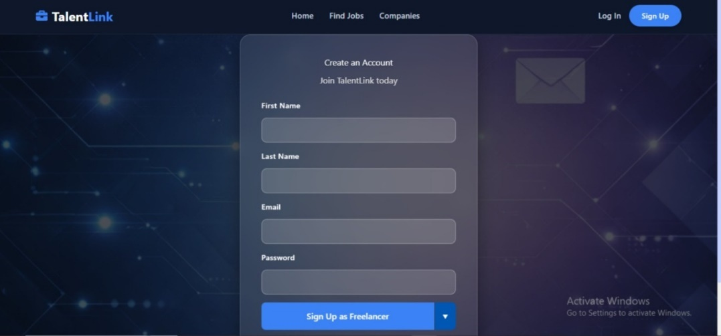
Fig 5.1: TalentLink Sign Up
Step 2: User Login
After successful registration, users can log in to the system using their credentials. Based on their role, they are directed to either the freelancer dashboard or the client dashboard.

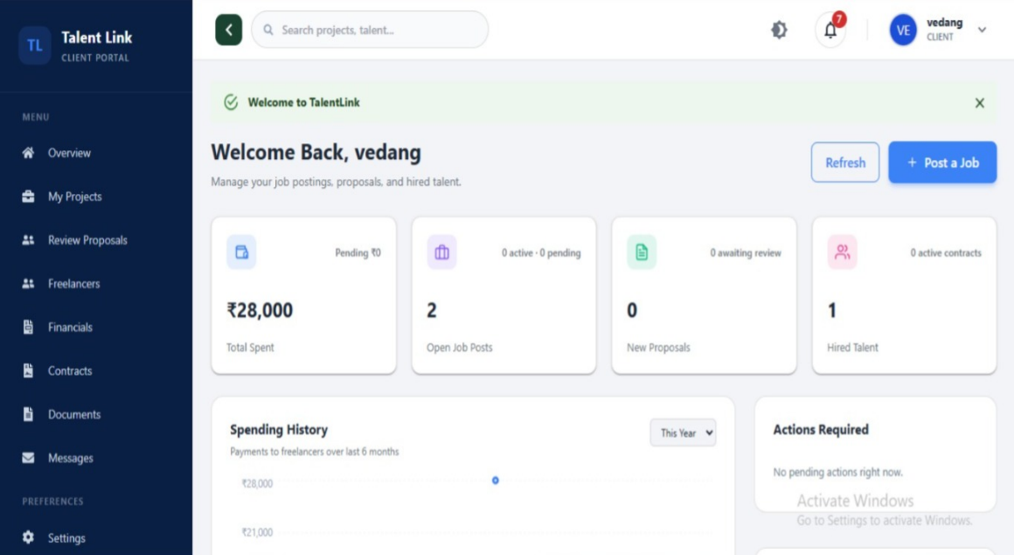
Fig 5.2: TalentLink client dashboard
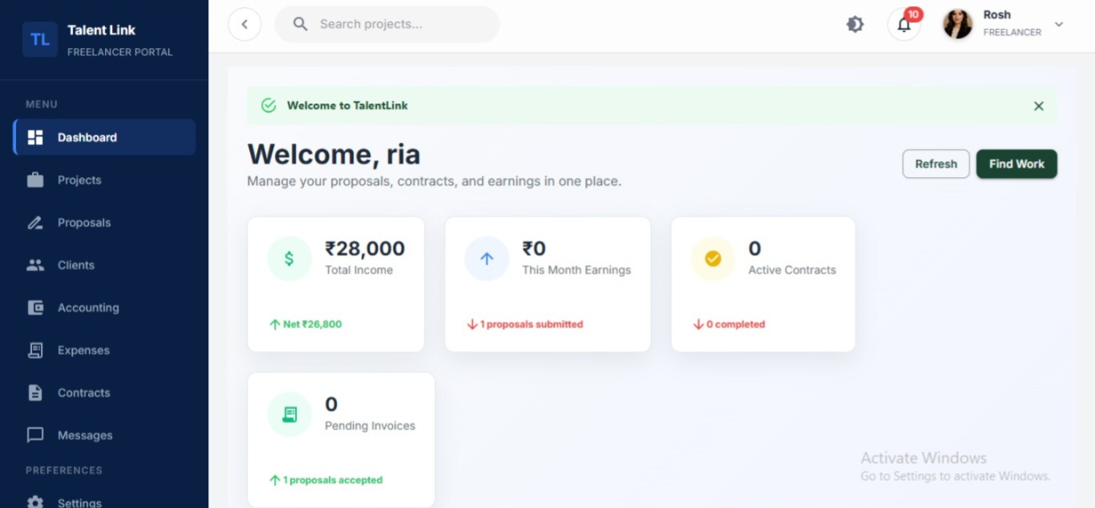
Fig 5.3: TalentLink Freelancer dashboard

Fig 5.4: TalentLink Login

Step 3: Profile Creation
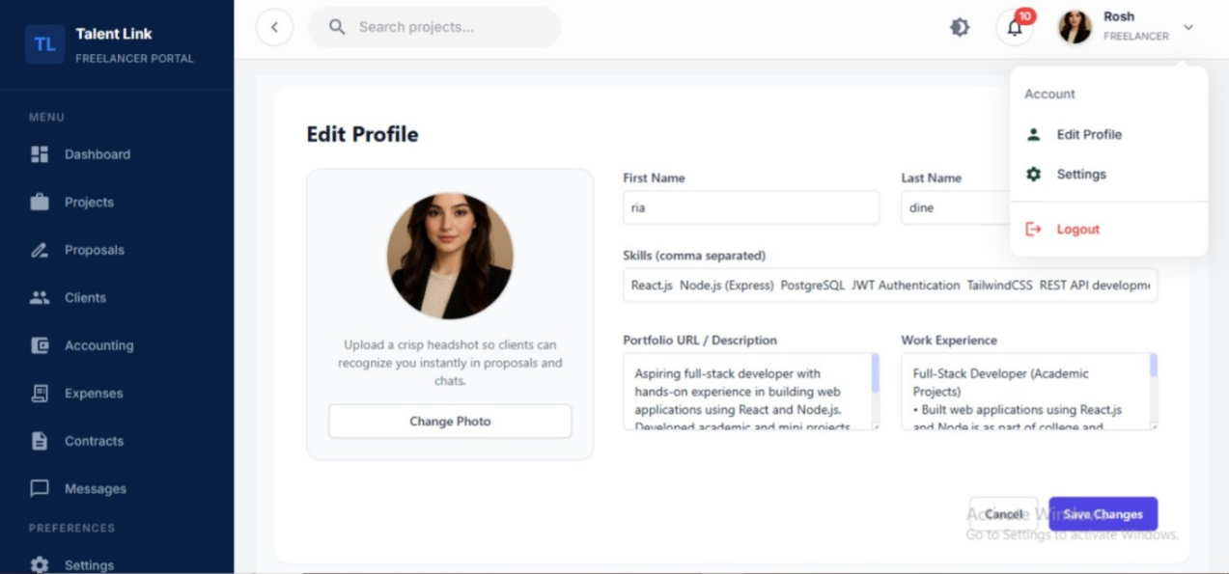
Fig 5.5: Profile Creation
Step 4: Project Posting
Clients can create and publish project listings with details such as project description, required skills, and deadlines.

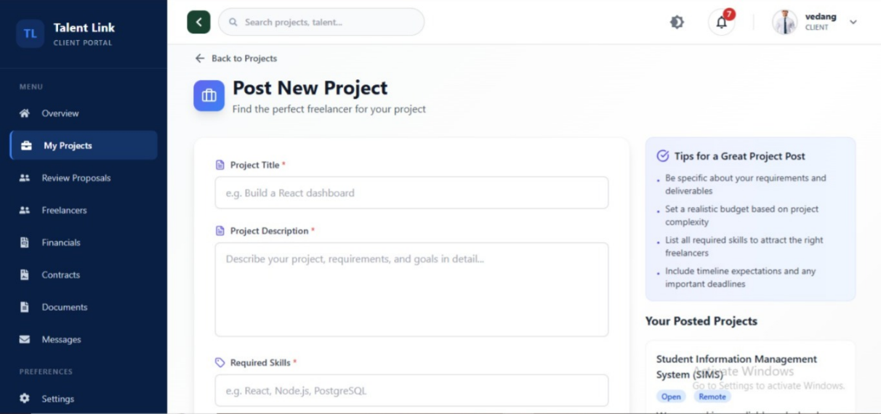
Fig 5.6: Post Project
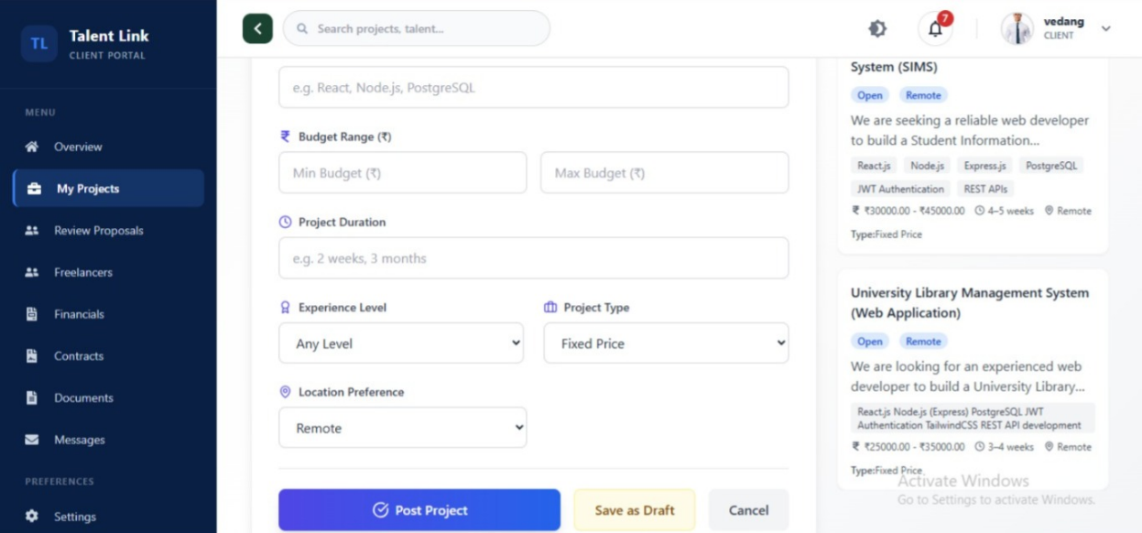
Fig 5.7: Post Project

Step 5: Proposal Submission
Freelancers can browse available projects and submit proposals explaining how they plan to complete the project.

Fig 5.8: Proposal Submission

Step 6: Project Selection
Clients review proposals submitted by freelancers and select the most suitable candidate for their project.

Fig 5.9: Project Selection

Step 7: Communication and Collaboration
Once a freelancer is selected, both parties can communicate through the platform and work on the project collaboratively.

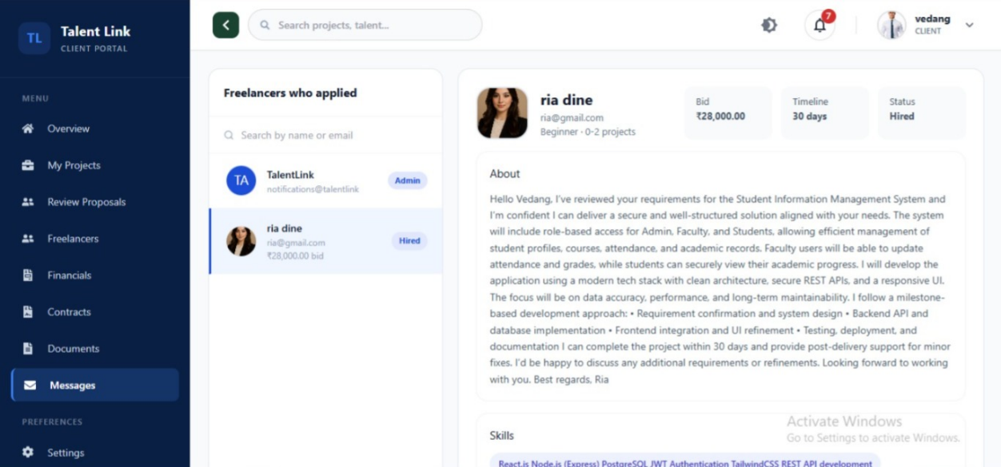
Fig 5.10: messaging

Step 8: Project Completion and Review
After completing the project, clients can provide feedback and ratings to freelancers, helping maintain transparency and trust in the platform.

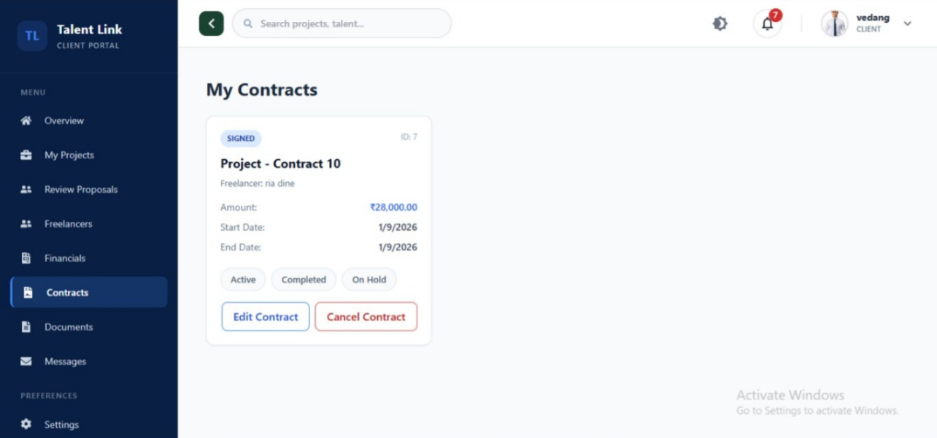
Fig 5.7: New Device Creation

CHAPTER 6
SYSTEM DESIGN

6.1 SYSTEM ARCHITECTURE

The system architecture of TalentLink follows a structured web application architecture that enables communication between users, the application interface, and the database. The platform is designed to provide a reliable environment where freelancers and clients can interact, manage projects, and collaborate efficiently.
The architecture consists of three main components: the frontend layer, the backend layer, and the database layer. The frontend layer provides the user interface through which clients and freelancers interact with the system. It allows users to register, log in, browse projects, submit proposals, and manage project activities.
The database layer is responsible for storing and managing all system data, including user information, project details, proposals, contracts, and reviews. The database ensures that information is stored securely and can be retrieved whenever required.
When a user performs an action on the platform, the request is sent from the frontend to the backend through application interfaces. The backend processes the request, interacts with the database to store or retrieve data, and then sends the response back to the frontend. This structured architecture helps maintain system efficiency, scalability, and organized management of freelance project activities.

6.1 USER FLOW DESIGN

A Data Flow Diagram (DFD) is a graphical representation of the flow of data within a system or process. It is a modelling technique that shows how data moves through processes and how it is stored, transformed, or exchanged within a system. DFDs are often used in system analysis and design to visualize and understand the data processing and flow of information in a structured manner.

Fig 6.2.1: User Flow Diagram for Garbage Bin

6.1 USER FLOW DESIGN

Unified Modelling Language (UML) is a standardized modelling language in the field of software engineering. It provides a way to visualize a system's design through a set of diagrams. UML diagrams help software developers and system architects communicate and understand the structure and behaviour of a system. In UML, the diagrams can be broadly categorized into two main types: structural diagrams and behavioural diagram.
1.Structural Diagram
Structural diagrams in UML focus on representing the static structure of a system. They showcase the components that make up the system and their relationships. The following are different structural diagrams:
- Class diagram
- Object diagram
- Component diagram
- Deployment diagram

2.Behavioural Diagram
Behavioural diagrams primarily capture the dynamic facet of the system. Dynamic aspects can be more delineated because of the dynamical or moving elements of a system.
UML has the subsequent 5 varieties of behavioural diagrams.
They are:
  - Use case diagram
  - Sequence diagram
  - Collaboration diagram
  - State Chart diagram
  - Activity diagram

6.3.1 Use Case Diagram

Use Case Diagrams in UML describe interactions between a system and external entities known as actors. Use cases represent specific functionalities or scenarios that the system provides to its users.

Fig 6.3.1: Use Case Diagram

6.3.2 Class Diagram

The Class Diagram in UML illustrates the static structure of a system, detailing classes, attributes, methods, and their relationships. Rectangles represent classes, and lines indicate associations, dependencies, and inheritances.

Fig 6.3.2: Class Diagram

6.3.3 Activity Diagram

Activity Diagrams represent the flow of activities within a process or workflow. They focus on actions, decisions, and control flows, providing a high-level view of the dynamic aspects of a system.

Fig 6.3.3: Activity Diagram

6.3.4 Sequence Diagram

A sequence diagram merely depicts interaction between objects in an exceedingly serial order i.e., the order during which these interactions turn up. We will conjointly use terms event diagrams or event eventualities to consult with a sequence diagram. These diagrams are widely employed by businessmen and software package developers to document and perceive needs for brand new and existing systems.

Fig 6.3.4: Sequence Diagram

CHAPTER 7
IMPLEMENTATION

The TalentLink platform was implemented as a full-stack web application designed to connect freelancers and clients through a structured and user-friendly interface. The system allows users to register and authenticate securely, after which they are assigned roles as either freelancers or clients. Clients can post projects by providing details such as title, description, budget, and required skills. Freelancers can browse available projects and submit proposals based on their expertise. The platform also enables clients to review proposals and select suitable freelancers for their projects, ensuring an organized hiring process.
The backend of the system manages user authentication, project management, proposal handling, messaging, and contract tracking. All requests from the frontend are processed through secure APIs and stored in the database for efficient retrieval and management. The system also supports communication between freelancers and clients and allows users to track project progress from proposal submission to completion. This structured implementation ensures transparency, efficient collaboration, and a smooth workflow for freelance project management.

7.1 INSTALLATIONS AND LIBRARIES USED

- Installation Steps
- Install Python and create a virtual environment.
- Install backend dependencies using pip from the requirements file.
- Install Node.js and npm for the frontend development environment.
- Install frontend dependencies using npm install.
- Configure the database connection for SQLite (development) or PostgreSQL (production).
- Run database migrations and start the backend server.
- Start the frontend development server to launch the application

7.1 CODE
import React from "react";
import "./App.css";
import "./assets/global.css";
import { BrowserRouter as Router, Routes, Route, Navigate } from "react-router-dom";

/* ===== Context Providers ===== */
import { UserProvider } from "./context/UserContext";
import { ProjectProvider } from "./context/ProjectContext";
import { ThemeProvider } from "./context/ThemeContext";
import { SearchProvider } from "./context/SearchContext";

/* ===== AuthFlow UI Pages ===== */
import Home from "./pages/Home";
import Login from "./pages/Login";
import Signup from "./pages/Signup";
import VerifyOtp from "./pages/VerifyOtp";
import ForgotPassword from "./pages/ForgotPassword";
import ResetPassword from "./pages/ResetPassword";

/* ===== Client Dashboard Pages & Layout ===== */
import ClientLayout from "./freelancer_layouts/ClientLayout";
import ClientDashboard from "./freelancer_pages/client/ClientDashboard";
import ClientProjects from "./freelancer_pages/client/ClientProjects";
import ClientFinancials from "./freelancer_pages/client/ClientFinancials";
import ClientContracts from './freelancer_pages/client/ClientContracts';
import JobProposals from "./freelancer_pages/client/JobProposals";
import ClientDocuments from "./freelancer_pages/client/ClientDocuments";
import ClientMessages from "./freelancer_pages/client/ClientMessages";
import ClientSettings from "./freelancer_pages/client/ClientSettings";
import ClientHelp from "./freelancer_pages/client/ClientHelp";
import ClientProfile from "./freelancer_pages/client/ClientProfile";
import EditClientProfile from "./freelancer_pages/client/EditClientProfile";
import Freelancers from "./freelancer_pages/client/Freelancers";

/* ===== Freelancer Dashboard Pages ===== */
import FreelancerDashboard from "./freelancer_pages/freelancer/FreelancerDashboard";
import Projects from "./freelancer_pages/freelancer/Projects";
import ProjectProposal from "./freelancer_pages/freelancer/ProjectProposal";
import FreelancerProposals from "./freelancer_pages/freelancer/FreelancerProposals";
import Accounting from "./freelancer_pages/freelancer/Accounting";
import Expenses from "./freelancer_pages/freelancer/Expenses";
import Inquiry from "./freelancer_pages/freelancer/Inquiry";
import Contracts from "./freelancer_pages/freelancer/FreelancerContracts";
import CalendarPage from "./freelancer_pages/freelancer/CalendarPage";
import Clients from "./freelancer_pages/freelancer/Clients";
import Reports from "./freelancer_pages/freelancer/Reports";
import Settings from "./freelancer_pages/freelancer/FreelancerSettings";
import Profile from "./freelancer_pages/freelancer/Profile";
import EditProfile from "./freelancer_pages/freelancer/EditProfile";
import FreelancerMessages from "./freelancer_pages/freelancer/FreelancerMessages";
import FreelancerLayout from "./freelancer_layouts/FreelancerLayout";
import FreelancerHelp from "./freelancer_pages/freelancer/FreelancerHelp";

/* ===== Notifications ===== */
import NotificationHome from "./notifications/features/notifications/pages/NotificationsPage";
import NotificationItem from "./notifications/features/notifications/components/NotificationItem";

/* ===== Optional 404 Page ===== */
import NotFound from "./freelancer_pages/NotFound";

import './App.css';

function App() {
return (
<ThemeProvider>
<UserProvider>
<ProjectProvider>
<SearchProvider>
<Router>
<Routes>
{/* ===================== */}
{/* PUBLIC AUTHFLOW ROUTES */}
{/* ===================== */}
<Route path="/" element={<Home />} />
<Route path="/login" element={<Login />} />
<Route path="/signup" element={<Signup />} />
<Route path="/verify-otp" element={<VerifyOtp />} />
<Route path="/forgot-password" element={<ForgotPassword />} />
<Route path="/reset-password" element={<ResetPassword />} />

{/* ===================== */}
{/* CLIENT PORTAL ROUTES */}
{/* ===================== */}
{/* Anything inside here gets the Sidebar + Navbar */}
<Route path="/client" element={<ClientLayout />}>
<Route index element={<ClientDashboard />} />

<Route path="dashboard" element={<ClientDashboard />} />
<Route path="projects" element={<ClientProjects />} />
<Route path="financials" element={<ClientFinancials />} />
<Route path="contracts" element={<ClientContracts />} />
<Route path="proposals" element={<JobProposals />} />
<Route path="freelancers" element={<Freelancers />} />
<Route path="documents" element={<ClientDocuments />} />
<Route path="messages" element={<ClientMessages />} />
<Route path="settings" element={<ClientSettings />} />
<Route path="help" element={<ClientHelp />} />

{/* --- MOVED HERE: Now it will have Sidebar & Navbar --- */}
<Route path="notifications" element={<NotificationHome />} />

<Route path="profile" element={<ClientProfile />} />
<Route path="profile/edit" element={<EditClientProfile />} />
</Route>

{/* ===================== */}
{/* FREELANCER ROUTES */}
{/* ===================== */}
<Route path="/freelancer" element={<FreelancerLayout />}>
<Route index element={<FreelancerDashboard />} />
<Route path="dashboard" element={<FreelancerDashboard />} />
<Route path="projects" element={<Projects />} />
<Route path="projects/:id" element={<ProjectProposal />} />
<Route path="proposals" element={<FreelancerProposals />} />
<Route path="accounting" element={<Accounting />} />
<Route path="expenses" element={<Expenses />} />
<Route path="inquiry" element={<Inquiry />} />
<Route path="contracts" element={<Contracts />} />
<Route path="calendar" element={<CalendarPage />} />
<Route path="clients" element={<Clients />} />
<Route path="reports" element={<Reports />} />
<Route path="settings" element={<Settings />} />
<Route path="messages" element={<FreelancerMessages />} />
<Route path="notifications" element={<NotificationHome />} />
<Route path="profile" element={<Profile />} />
<Route path="profile/edit" element={<EditProfile />} />
<Route path="help" element={<FreelancerHelp />} />
</Route>

{/* ===================== */}
{/* 404 & Fallbacks */}
{/* ===================== */}
{/* Note: I commented out the standalone /notifications since we moved it into /client */}
{/* <Route path="/notifications" element={<NotificationHome />} /> */}

<Route path="/notifications/:id" element={<NotificationItem />} />
<Route path="/404" element={<NotFound />} />
<Route path="*" element={<Navigate to="/404" />} />

</Routes>
</Router>
</SearchProvider>
</ProjectProvider>
</UserProvider>
</ThemeProvider>
);
}

CHAPTER 8

RESULTS

This section describes step-by-step the system analysis and the results obtained. The system was designed and simulated in proteus and a working prototype was developed using the different hardware components with data being sent to the mobile application.

CODE OUTPUT:

CHAPTER-9
FUTURE SCOPE

While the TalentLink platform successfully provides a structured environment for connecting freelancers and clients, there are several opportunities for further improvements and enhancements. As the demand for digital freelance platforms continues to grow, the system can be expanded with additional features to improve efficiency, user experience, and scalability.

The future scope of the TalentLink platform includes the following enhancements:
- AI-Based Project Matching:
Implement intelligent algorithms that automatically match freelancers with suitable projects based on skills, experience, and project requirements.
- Advanced Communication Tools:
Integrate real-time chat, video communication, and file sharing features to improve collaboration between freelancers and clients.
- Secure Payment Integration:
Add secure online payment systems to manage project payments, milestones, and financial transactions within the platform.
- Mobile Application Development:
Develop a mobile version of the TalentLink platform to allow users to access freelance opportunities and manage projects from anywhere.
- Enhanced Rating and Review System:
Improve the feedback system to help clients evaluate freelancers more effectively and maintain trust within the platform.

CHAPTER-10
CONCLUSION
The TalentLink platform provides a structured and efficient solution for connecting freelancers and clients in a professional environment. With the increasing demand for remote work and freelance services, there is a need for reliable platforms that simplify the process of hiring skilled professionals and managing project collaborations. TalentLink addresses these needs by providing a centralized system where clients can post project requirements and freelancers can discover and apply for suitable opportunities.

The system improves collaboration by enabling organized communication, proposal submission, and project tracking throughout the project lifecycle. By offering a structured workflow, TalentLink helps reduce communication gaps and improves transparency between freelancers and clients. The platform also allows freelancers to showcase their skills and experience, helping clients identify suitable professionals for their projects more efficiently.

Overall, TalentLink contributes to improving the freelance hiring process by providing a reliable and organized platform for project collaboration. The system enhances efficiency, transparency, and communication in freelance project management. In the future, the platform can be further enhanced with advanced features such as intelligent project matching, improved collaboration tools, and scalability to support a larger number of users in the growing digital economy.

